Machine Learning - An Era of Machines

**Meta Title:** "Machine Learning - An Era of Machines: Unlocking the Future of Technology"

**Meta Description:** "Dive into the exciting field of machine learning, where AI and data-driven algorithms are reshaping established sectors and paving the way for cutting-edge innovations. Learn how machine learning is changing the world, as we know it by exploring its cutting-edge developments, practical applications, and formidable hurdles. Come with us as we explore the future of technology and the boundless possibilities it holds.

# Introduction

Machine learning is an AI application that enables unprogrammed system learning and improvement via experience. Developing computer programs that can access data and utilise it to learn independently is the focus of machine learning.

The process of data analysis known as machine learning may automatically create analytical models of data sets. It is an area of artificial intelligence that computer systems can learn from data, recognise patterns, and make decisions with little or no intervention from a person.

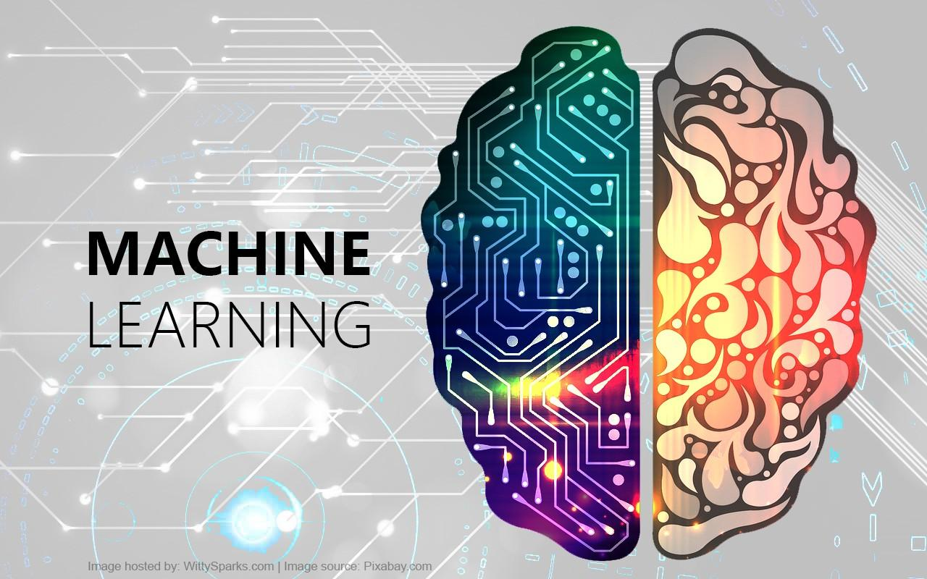

It allows computers and machines to act on their own, based on the information they have gathered, rather than following strict instructions. These algorithms or programs are created to be able to adapt to new information and get better as time goes on.

# Historical Perspective on Machine Learning

Ten years ago, no one would have predicted the meteoric rise of artificial intelligence (AI) in the marketing industry. Timely advancements in machine learning provide insight into this phenomenon.

Machine learning emerged as a scientific area in the 1940s and 1950s, with the creation of early computing models and the birth of artificial intelligence (AI). The study titled "A Logical Calculus of Ideas Immanent in Nervous Activity," conducted in 1943 by Warren McCulloch and Walter Pitts, proposed the concept of M-P neurons as a computational framework for neural networks. An artificial intelligence milestone that laid the groundwork for machine learning in its early stages. It is fascinating to find out that something conceptually similar to machine learning has been around for so long. Alan Turing, often called the "father" of modern computer science, created one of the earliest learning machines based on artificial intelligence. He called it the Turing Learning Machine.

It is important to note, however, that machine learning is not limited to the use of AI. It is a branch of AI where sophisticated algorithms are used to "learn" something new from existing data. In addition, machine learning allows computers to adapt their algorithms to meet their own specific needs.

These days, machine-learning algorithms are all around us, doing everything from chatting with us to compiling reports to writing content to sending messages to detecting and preventing fraud.

Looking back, we can see that academic institutions were crucial to the development of machine learning. If we go back in time, we can see this for ourselves. In order to tackle the difficult task of machine learning, researchers looked to the field of statistics for guidance.

When Alan Turing finished his first AI machine in 1950, it was revolutionary (AI). Even more so, by the 1980s, expert systems had become the norm in their respective fields.

In the early days of machine learning, pattern recognition and data behaviour were its primary concerns. It is crucial to remember that AI was meant to be machine learning's final destination from the start. Despite this, by the 1990s, it had matured into a systematic approach to dealing with major challenges.

# This short history charts the development of machine learning in general.

* Alan Turing conceived the concept of the first “Learning Machine” in 1950.
* Arthur Samuel created the first machine-learning program in 1952. This application was conceived based on the timeless board game of checkers. Machine learning allowed the computer to get better at its programmed task as it was used.
* In 1981, Gerald Dejong introduced the world to the concept of Explanation-Based Learning. (EBL). To a certain extent, computers can now be trained to distinguish between important and unimportant data.
* Terry Sejnowski originally conceived NetTalk in 1985. The software may eventually be able to learn how a newborn would pronounce words.
* IBM’s Deep Blue computer defeated Gary Kasparov, the reigning world chess champion, in 1997.
* Torch, a machine-learning software library, made its debut in 2002.
* In 2006, Netflix announced a public award called "The Netflix Prize." Participants used machine learning to outperform Netflix’s own recommendation system in a contest.
* Kaggle, an online platform for machine learning competitions, launched for the first time in 2010.
* During a 2011 Jeopardy! Competition, IBM's Watson competed against and beat out two human competitors. With NLP, IR, and machine learning techniques to better understand user intent.
* In 2012, the Google Brain team created a neural network based on machine learning. Unlabelled still images extracted from YouTube videos were sufficient for this network to identify cats correctly.
* Utilizing a neural network, DeepFace, a piece of face-recognition software, was able to achieve a 97.35% success rate in 2014. Facebook's research team has been working tirelessly to improve the quality of this machine-learning project.
* When it comes to machine learning, Sibyl is the go-to platform for massively parallel processing. That year, 2014, saw its release. This platform is used internally at Google to make forecasts about user behaviour.
* In 2015, Amazon released its own AI system.
* AlphaGo, developed by Google in 2016, was the first computer program to defeat a human Go player using machine-learning techniques.
* It is hard to imagine a sector where machine learning will not have a major effect on processes by 2020.

# **How exactly does "machine learning" operate?**

The first step of Machine Learning is to select an algorithm and then feed that algorithm training data. Training data can consist of either known or unknown information, and it is used to create the final machine-learning algorithm. The input training data can have an effect on the algorithm, a topic that will be discussed in detail in a moment.

It is necessary to provide the Machine Learning algorithm with fresh input data so that it can be evaluated for proper operation. Following this, the prediction and results are examined.

If the prediction does not match what was expected, the algorithm is retrained a large number of times to find the desired output. This allows the Machine Learning algorithm to continuously learn and produce the optimal answer, while also allowing the algorithm's accuracy to increase gradually over time.

Learner, model, and parameters are the three most essential elements of a system.

* The model is the system employed for making predictions.
* The model's predictions are based on the parameters, which are the factors it takes into account.
* It is the responsibility of the student to make any necessary modifications to the model and its parameters to ensure that the predictions are consistent with the data.

A machine-learning model is tasked in this scenario with determining whether the beverage being consumed is beer or wine. As parameters, the colour of the beverage and the amount of alcohol have been established. The initial step is as follows:

1. Using the knowledge gained from the practise set

In order to accomplish this, it is necessary to collect a sample data set containing information about the colour and alcohol content of various beverages. We can now proceed to defining the description of each classification, which in this case includes wine and beer, in terms of the values of the parameters that apply to each type. Based on the description, the model can determine whether a new beverage is a beer or wine.

You can represent the values of the parameters 'colour' and 'alcohol percentages' using the letters 'x' and 'y', respectively. The values of each drink in the training data are then used to define its parameters (x, y). This particular collection of data is referred to as a training set. The hypothesis that best fits the desired results is presented in the form of a line, a rectangle, or a polynomial when these values are plotted on a graph.

1. **Measure error**

After the model has been trained with a specific training set, it must be examined for inconsistencies and errors. In order to accomplish this task, we utilise recently gathered data. This examination would yield one of the four possible outcomes:

* A True Positive is achieved when the model correctly predicts the presence of the condition when it is present.
* True negative — when a model fails to predict the presence of a condition when it is not present.
* False Positive: When a model predicts the presence of a condition when it actually does not exist
* False Negative: When a model fails to predict the presence of a condition that actually exists

The total model error can be calculated by adding FP and FN together

1. **Manage Noise**

In an effort to keep things as simple as possible, we have restricted our consideration of the machine-learning problem at hand to just two parameters: colour and alcohol content. In contrast, in order to solve a problem involving machine learning, you must consider hundreds of parameters and a wide variety of learning data.

* Because of the noise, the subsequent hypothesis will contain a great deal more errors. Noise refers to unintended irregularities in a data set that obscure an underlying relationship and make the learning process more challenging. There are numerous causes of this noise, including the following:
* Large training data set
* Errors in input data
* Data labelling errors
* Unobservable characteristics that could affect classification but were not considered in the training set due to a lack of pertinent information.

If you want the hypothesis to be as simple as possible, you can accept that there will be some amount of noise-induced training error.

1. Evaluation and Expansion of the Scope

Although it is possible for an algorithm or hypothesis to have a good fit to a training set of data, this does not guarantee the same success when applied to a different set of data that was not included in the training set. As a result, it is of the utmost importance to determine whether the algorithm can handle the new data. The best way to evaluate this is to put it to the test using recent data. Moreover, generalisation refers to the precision with which a model can predict the outcomes of an experiment using an entirely new set of data.

When we optimise a hypothesis algorithm to be as simple as possible, the algorithm may have fewer errors when processing the training data, but it may have significant errors when processing new data. This is referred to as under-sizing. On the other hand, if the hypothesis is too complex to accommodate the best fit to the training data, it may not generalise well. This demonstrates excessive conformity. In either case, the results are resubmitted into the model in order to train it.

Types of machine learning

## Machine learning can be broken down into three main groups.

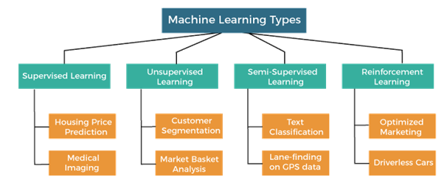

<https://static.javatpoint.com/tutorial/machine-learning/images/types-of-machine-learning2.png>

1. Supervised learning:

Supervised learning entails using labelled data with input X and a label Y to learn. Our aim in supervised learning is to determine the mapping between the input variable (X) known as the independent variable and the output variable (Y) known as the dependent variable. Supervised learning may also be classified into two categories of tasks:

Regression is an issue that occurs when the output variable is continuous and has a real value. For example, price, weight, and so on.

Classification — when the output variable is a category, such as "red" "blue," "illness" or "no disease," classification is difficult.

1. Unsupervised learning:

Unsupervised learning occurs when there is just input data (X) and no output variables. Unsupervised learning seeks to understand the underlying structure or distribution of data in order to learn more about it. Unsupervised learning may also be classified into two sorts of tasks:

Clustering: A clustering problem is one in which you wish to uncover the underlying groups in data, such as categorising consumers based on their purchase activity.

An association rule learning issue is one in which you wish to find rules that explain substantial chunks of your data, such as persons who purchase X also tend to buy Y.

1. Reinforcement learning:

In the context of artificial intelligence, reinforcement learning is a sort of dynamic programming that teaches algorithms using a reward and punishment system. The agent is rewarded for proper performance and penalised for faulty performance. The agent learns without the need for human intervention by maximising its reward and minimising its cost.

# Leading Machine Learning Methods

Now, let us examine some of the most popular machine learning techniques that fall under the Machine learning Methods categories.

1. Regression

When the output is a real or continuous value, regression techniques are typically used to generate numerical predictions. Since it falls under the category of Supervised Learning, it uses training data to predict new test data. The objective of regression techniques is to use a set of historical data to explain or predict a particular numerical result. In the case of retail demand forecasting, regression algorithms can utilise historical pricing information to predict the cost of a comparable property.

Using regression algorithms, one can anticipate continuous responses, such as fluctuations in temperature or power consumption. The forecasting of electrical load and algorithmic trading are two examples of common applications.

For data sets and responses including real values, such as temperature or the time before equipment breakdown, regression techniques are advised.

A regression model can be trained using multiple pairs of data, such as x and y. To do so, you must first determine the position and slope of the line at a minimum distance from all known data points. This line most closely estimates the data's observations. It is used to make predictions for previously unobserved data.

According to Educuba, the following are some of the most frequently used regression algorithms.

* Simple Linear Regression Model
* Lasso Regression
* Logistic Regression
* Support Vector Regression (SVR)
* Algorithm for Multivariate Regression
* Multiple Regression Method

1. Classification

A classification model is a Supervised Learning technique that generates one or more categorical outputs from observed values. Numerous AI applications require classification, but ecommerce applications benefit the most from it. For instance, classification algorithms can help predict whether a buyer will purchase a product. In this instance, the two categories are "yes" and "no." Classification algorithms are not restricted to two categories and can be used to categorise materials into numerous groups. The Classification model employs numerous techniques, such as Logistic Regression and Multilayer Perception, among others. In this model, we divide our data into distinct categories and label them accordingly.

Two types of classifiers exist:

* + Binary classifiers are those with two distinct classifications and two outputs.
  + Multiple-class classifiers are referred to as Multi-class classifiers.

1. Clustering

Clustering is an approach to Machine Learning for classifying data points into distinct groups. If we have a collection of objects or data points, we can use a clustering technique to analyse and categorise them according to their characteristics and traits. This unsupervised procedure is utilised because of its statistical approaches. Cluster algorithms utilise training data to make predictions and form groups based on similarity or dissimilarity.

Methods of unsupervised learning include clustering algorithms. Three popular clustering techniques include K-means clustering, mean-shift, and expectation-maximization. They organise data points into groups based on shared or similar characteristics.

Grouping or clustering techniques are highly effective in business applications when massive amounts of data must be segmented or categorised.

Several Clustering Methods are provided below:

* Density-based procedures
* Hierarchical procedures.
* Partitioning strategies
* Grid-based procedures

1. Decision Diagram

It is a supervised learning algorithm that is frequently applied to classification problems. Using this method, we divide the population into two or more homogenous groups. This is done in order to create as many distinct groups as possible based on the most vital characteristics/independent variables.

According to MobiDev, the Decision tree algorithm classifies objects by responding to "questions" about their characteristics at nodes. One of the branches is selected based on the response, and another question is posed at the next junction until the algorithm reaches the "leaf" of the tree, which represents the final solution.

1. Neural Systems

Neural networks are designed to resemble the structure of the brain: each artificial neuron connects to a large number of other neurons, and millions of neurons collaborate to form a complex cognitive structure. Neural networks have a multi-layered structure: neurons in one layer transmit data to numerous neurons in the next layer, and so on.

Eventually, the data reaches the output layer, where the network decides how to handle a problem, classify an object, etc. The study of neural networks is referred to as "deep learning" due to their multi-layered architecture.

Neural networks have the potential to be used in the telecommunications and media industries for a wide range of applications, including machine translation, fraud detection, and virtual assistant services. In the financial industry, they are used to detect fraud, manage portfolios, and assess risk.

1. Anomaly Discovery

Identifying unexpected items or events in a data set is called Anomaly Discovery. Detection of fraud, failure detection, monitoring of computer health, and other applications use this technology. There are three distinct classes for anomaly detection:

* Point anomalies: When a single data point deviates from the norm, this is known as a point anomaly.
* Contextual anomalies are context-specific anomalies.
* Collective anomalies: A collective anomaly is a group or collection of linked data elements that exhibit anomalous behaviour.

Potential Applications for Machine Learning

1. Social networking site functions

Some of the most engaging and effective features of contemporary social media platforms are the result of machine learning algorithms and techniques. Facebook, for instance, keeps track of your chats, likes, comments, and time spent on various post categories. Thanks to machine learning, automated profile enhancements, and friend suggestions are now a possibility.

1. Recommended Products

The use of machine learning in product recommendation is one of the most visible and well-known applications of this technology. In a striking illustration of the sophisticated application of machine learning techniques, nearly every e-commerce website now offers product recommendations. Websites use artificial intelligence and machine learning to analyse your browsing habits, shopping cart contents, and purchase history in order to recommend products and services that you may be interested in.

1. Image Recognition

Image recognition is one of the most important and well-known applications of machine learning and artificial intelligence. It is a technique for cataloguing and detecting a feature or object in a digital image. Pattern recognition, face detection, and facial recognition are just a few of the areas where this method is being utilised extensively for in-depth research.

1. Analysing Feelings

Sentiment analysis is the most important use case for machine learning. In the field of sentiment analysis, which attempts to determine the author's emotional state, machine learning in real-time is utilised. A sentiment analyser can determine the author's intended meaning and tone in any written piece, such as a review, email, or document, with speed and precision. This sentiment analysis software could be advantageous for a review-based website, a decision-making app, etc.

1. Controlling Employee Access through Automation

Businesses are increasingly utilising machine learning algorithms to determine what levels of access employees require to various company areas. Simply put, this is one of the most intriguing applications of machine learning.

1. Conservation of Marine Animals

Thanks to behaviour models developed with the aid of machine learning algorithms, scientists can better control and monitor populations of endangered cetaceans and other marine species.

1. Managing Medical Productivity and Care Quality

Major medical fields are investigating the application of machine learning algorithms to administration in an effort to enhance it. They estimate the length of time patients will be required to wait in the emergency waiting rooms of various hospital departments. In order to define the algorithm, the models incorporate essential information such as staffing levels across shifts, patient histories, departmental conversations, and the physical layout of emergency rooms. Detection of disease, preparation of therapy, and prognosis all involve the application of machine learning algorithms.

1. Predict the Heart Failure Risk

Scientists have developed an algorithm that can extract relevant information about a patient's cardiovascular history from free-form electronic notes. Computers now perform an analysis based on available data, eliminating the need for a physician to sift through multiple health records to make an accurate diagnosis.

1. The Financial Sector

In order to combat fraud and protect customer accounts from cybercriminals, financial institutions have adopted the most advanced available machine learning technology. The algorithms determine which criteria should be employed when designing a filter to prevent harm. If a website is determined to be fraudulent, payment processing will be immediately blocked.

1. Translation of Languages

The translation is a popular application of machine learning. Machine learning plays a critical role in the translation process. Websites can now translate effortlessly from one language to another and provide context for the translation. The translator is powered by the technology of machine translation. Without it, modern life would be considerably more challenging. Due to the elimination of the language barrier, businesspeople and tourists alike now feel more comfortable traveling to foreign countries.

# Importance of Machine Learning

One of the most long-familiar sub-fields that falls under the umbrella of Artificial Intelligence is Machine Learning. Concepts from machine learning are utilised in virtually every industry imaginable, including but not limited to healthcare, finance, infrastructure, marketing, self-driving cars, recommendation systems, chatbots, social networks, gaming, and cyber security, to name just a few.

The almost endless amount of available data, inexpensive data storage, and the advent of less expensive and more powerful processing have all spurred the growth of ML. Several industries are developing models that are more robust in order to analyse larger and more sophisticated data sets. It gives faster and accurate responses on a broad scale. With the aid of ML technologies, businesses may quickly identify attractive ideas and prevent excessive risks.

Data mining and interpretation are being revolutionised by machine learning. As a result, manual statistical approaches have been abandoned in favour of automated, general sets of procedures.

The practical applications of machine learning may have a big influence on the bottom lines of businesses. Rapid technical breakthroughs have substantially expanded the possible applications of machine learning. Industry sectors that rely on enormous volumes of data and require a system to analyse it fast and precisely in order to generate models, establish strategies, and plan have embraced machine learning.

# Benefits of using Machine Learning

1. Estimating the Value of a Customer Over Time

It is widely used in modern businesses and is often abbreviated as CLV. However, it is a fact that this number has an effect on forecasting sales, both now and in the future. Due to the massive amounts of data that businesses possess, ML algorithms can be trained to extract relevant business insights, which improves the accuracy of the prediction made through supervised learning. If you can retain just 20% of your customers, you can rest assured that your business will make up 80% of its revenue. This is according to Gartner's customer insights. In addition, CLV is crucial in determining the likelihood of a consumer making a particular action, such as making a purchase or determining whether a product is worth investigating further.

Approximately 66% of marketers' interactions with sales representatives resulted in the creation of highly effective customers, according to the reports. About 45% of deals have reached their objectives. These deals have been measured by LTV's fundamental value. Furthermore, this metric is accurate for tracking 26% of sessions, although other percentages are also mentioned. Senior marketers are placing a greater emphasis on customer retention and strategically directing attention using various CLV metrics. There are a number of supervised and unsupervised Machine learning methods at play here, all of which contribute to the overall financial and economic success of the enterprise.

1. Automating for Smarter Decisions and Streamlining Operations

The most common and significant issues that modern business face are related to the existence of duplicate and inaccurate data. About 29% of all data on the web are duplicates, so automating this process is essential. The companies have little to worry about, as they can potentially consume error-free Predictive modelling algorithms in their processes consisting of automated procedures. Such processes will recognise duplicate rows and columns and, using the newfound knowledge, will be able to distinguish anomalies accurately. This means that large corporations can relax knowing their employees no longer care about the benefits of machine learning to businesses. For one thing, the database they use has the potential to reveal unnecessary expenditures, unrealized gains in sales and revenue capital, and inaccurate reporting that has contributed to a decrease in customer retention rates. Risks resulting from obstacles like poor communication or performance metrics are also spotted in time to be overcome. Since a high decision-making value will reliably increase a company's profit margins, that company can now devote more time to streamlining its operations.

1. Predictive Maintenance

Manufacturing companies that invest in preventative maintenance are better able to implement procedures that cut costs and increase output quality. Problems are predicted, and approaches to solving them are monitored, using data from the past as well as the present. Here, unsupervised learning algorithms help a great deal by reducing the number of failures and risks associated with gaining useful insights. The workflow visualisation tools used to implement predictive maintenance hold great promise for reducing wasteful spending, which bodes well for the market's scalability. Since assets can be linked effectively with fewer criticalities, businesses can now conceive of providing valuable performances. To get a feel for how big the predictive maintenance market is likely to be, we will look at this diagram.

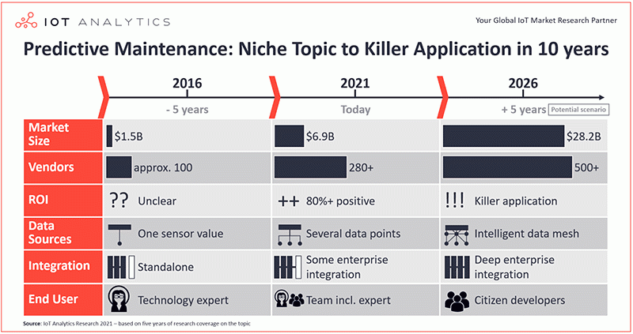

[*https://i0.wp.com/iotbusinessnews.com/WordPress/wp-content/uploads/predictive-maintenance-niche-to-killer-app.gif?resize=800%2C423&ssl=1*](https://i0.wp.com/iotbusinessnews.com/WordPress/wp-content/uploads/predictive-maintenance-niche-to-killer-app.gif?resize=800%2C423&ssl=1)

* In 2021, the predictive maintenance market could be worth 6.9 billion dollars, and it is expected to grow to $28.2 billion by 2026. This represents an annualised growth rate of 31%.
* Start-ups' success in 2021 can be tracked with relative ease, thanks to the 280+ solution providers who are standing by to lend a hand with tried-and-true methods from around the world. By 2026, there will be at least 500 devoted vendors in this space.
* Businesses as they currently stand will be remodelled based on an analysis of trends in things like downtime, repair costs, and manufacturing processes. The fact that the ROI is expected to be 80% or higher by 2021 sheds light on the matter. When we get to the year 2026, all of this will make investments appealing, and we can anticipate killer applications of ML.

Each of these benefits aids businesses by increasing their knowledge of risk-free transformations. Predictive modeling, a form of machine learning, can be used to help keep existing assets in good shape, which can lead to increased visibility and revenue.

1. Scalability with Reduced Expenses

In this sense, scalability refers to an organization's potential to expand in terms of both size and scope. If a business wants to get better results and make more money, it must make bigger investments at the start of its scalability journey. Despite this, semi-supervised Machine Learning algorithms correctly label the graph-based predictions, allowing businesses to benefit from a more in-depth understanding of their customers and a rise in brand loyalty. With the advent of Machine Learning tools that are well versed in preventive maintenance, all of this is possible, which bodes well for the much-needed reduction in equipment breakdowns.

It is possible that as ML develops and adapts to new market conditions, businesses will be able to adopt new approaches to increasing sales. These may include things like focusing on potential dangers connected to keeping and satisfying customers, offering helpful feedback on products, etc. Semi-supervised ML's highlighted classification and prediction graphs are useful for estimating such factors. Strategies with hints of Machine Learning will invite higher yields ahead of the expected period, so businesses will not need to adopt additional solutions for mitigating current risks and scaling well.

1. Statistical Evaluation of the Budget

It is undeniable that financial analysis is a comprehensive look at your company's assets. Companies can now boost output and expand their operations with the help of ML's qualitative and quantitative methods. As we proceed, we will examine how the algorithmic analysis of ML in finance can automate processes.

Approximately 54% of accounting and finance-related ML analysis can gamify the interpretation of historical and current data. Automated applications supporting security, compliance, credit-score management, and so on also do a good job of handling taxes and internal audits. However, chatbots are also used in industries to eradicate supplier inefficiencies, doing away with the complications of traditional financial principles in the process.

1. Recognizing Pictures

Automotive, retail, healthcare, marketing, and e-commerce are just some of the most common sectors where it is implemented. Businesses can use this to foresee consumer behaviour, enhance image optimization and recognition, and give their apps a new perspective. Adding this to the list of significant business effects of machine learning. This tool can also efficiently extract meaningful numerical and symbolic data from high-dimensional datasets, such as images. Because Image Recognition aids applications in automatically organising content and identifying the images attracting the attention of customers, businesses will not have to wait as long for technological breakthroughs.

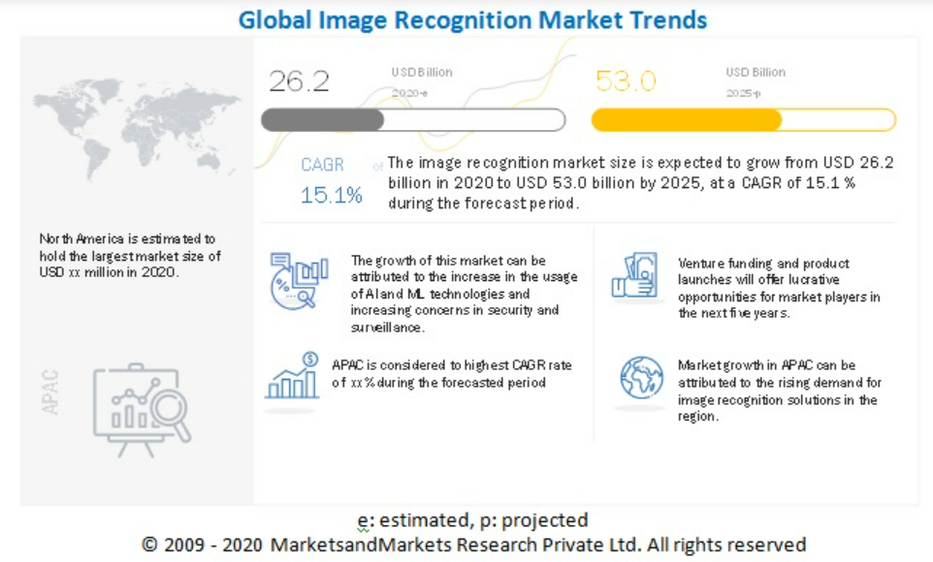

[*https://www.marketsandmarkets.com/Market-Reports/image-recognition-market-222404611.html*](https://www.marketsandmarkets.com/Market-Reports/image-recognition-market-222404611.html)

The image recognition market is projected to grow from its 2021 value of $26.2 billion to its 2025 value of $53.2 billion. Based on that, it seems reasonable to conclude the following. In light of the future benefits of Image Recognition in terms of security and flexibility, businesses are prepared to make the necessary investments.

1. Boosting Customer Happiness by Segment

Unsupervised learning is preferred over supervised learning for making recommendations about high quality, low quality, and other categories of products. The overarching goal is to tailor the experience that a product offers to each buyer based on his or her tastes and the state of the market. Here, Machine Learning is beneficial because it gradually identifies the purchase history and user's interests, which is useful for businesses in the medical, construction, accounting industries. Over time, self-directed teams will learn to recognise and categorise product inventories that prioritise the needs of their customers and provide satisfying experiences for their users. Using this method, hidden patterns that can drive product purchases or expose latent dangers in the grouped or ungrouped items can be recycled or eliminated. Therefore, businesses have been able to streamline operations, improve conversion rates, increase engagement with recommended content, and fine-tune merchandising without having to devote as much time and energy to keeping track of inventory.

Certainly, the analytics employed in ML have made it possible to predict the propensity of categorised customers to subscribe. To serve better, their differentiated customer bases, businesses can now leverage the information contained within their enterprise data.

The degree to which they are similar or different depends on factors such as the individual's preferences, values, personality traits, income, level of education, and the ways in which they plan to put the product or service to use. Here, churn protection can be an effective preventative strategy, allowing businesses to keep customers and compelling them to continue using the company's services.

This is accomplished when the call history is properly segmented based on customer behaviour analysis and ML models are used to assign correctly client requirements. It has helped businesses a great deal to see cost savings in real-time, and they have also saved a lot of time and effort in the relationship management process. That is why big businesses love predictive algorithms: they guarantee satisfaction among specific groups of customers by providing them with products and services that are tailored to their specific needs.

1. Strengthening Cybersecurity

The use of ML to strengthen a company's defense is highly beneficial. Pattern detection and real-time crime mapping offer flexible solutions to pressing cybersecurity issues. In this case, Ml (Machine Intelligence) will fortify the next-generation cybersecurity protocols that can detect previously unknown threats accurately and quickly.

Unsupervised learning's computational mathematics also brings adept modeling to penetration testing. As a result, all the software used by cybersecurity firms will function in accordance with all applicable regulations and guidelines. This is because compromised networks will be safe behind application firewalls. Both the static and the dynamic analysis of unstructured data are not vulnerable to attacks like phishing. Since the means by which cyber criminals once gained access to networks and their data have not been eradicated, this protects businesses from further attacks.

1. Provisions Extraction Using Pattern Detection

Corporations can use pattern detection to spot patterns in either labelled or unlabelled data. Using those regularities as a basis for training, ML algorithms could be developed to detect market trends with greater dimensionality. In addition, such routines will employ intricate analytic techniques to record accommodations for the typical difficulties encountered in business. Either change in the law or technological progress can provide the impetus for the expansion of a company's operations that is necessary to achieve the set goals in terms of revenue and size.

After a company has determined its long-term objectives, it can turn to supervised or semi-supervised Machine Learning algorithms for guidance by using the hidden patterns those algorithms have discovered to secure funding from reputable sources (these may be the potential investors of the organisations connected for longer times or the customers with higher income slabs). A company's ability to quickly gather pertinent insights and strengthen its decision-making process is greatly enhanced by the ability to detect patterns of change or stagnation. This is because ML's pattern detection technique has aligned well with the real-time use cases of complex or mid-sized business standards that agree most prominently with the likelihood of success.

1. Introducing Real-Time Pricing

You could think of it as a form of variable pricing. In a time of crisis, this simple method can work wonders when coupled with business opportunities. In addition to this, companies have done well even in this second layer thanks to the adoption of varying pricing labels over the available items. The list includes many well-known brands, including Walmart, Amazon, Uber, Airbnb, EasyJet, and many more. All of them have adopted Machine Learning algorithms like deep learning, supervised learning, and semi-supervised learning, which have taught them the following: -

* Basic Expenses
* Unique situations that are currently occurring or will in the future
* Seasonality
* Costs set by rivals in response to domestic or global demand

Dynamic product/item pricing by businesses yields laudable market-driven ideas. This is because, by estimating different types of demand and supply from target customers, these ML algorithms help businesses generate pricing suggestions. Segmented customers' psyches are then mapped in relation to how their interest in particular products evolves over time.

As a result, ML algorithms can perform price discrimination while taking into account both the high- and low-value customer bases. A company can gain an advantage over its rivals by adopting a pricing strategy that is in step with current trends thanks to improved tracking of behavioural anomalies. By dynamically changing the price as the customer shops, the business can increase its profit margin beyond the standard 25% and keep more of what it earns from each sale.

# Machine learning and its Challenges:

1. Inadequate Data Quality

For machine learning to work, data is crucial. The lack of high-quality data is a major challenge for machine learning experts. The process can become very draining if the data is dirty or noisy. We cannot have our algorithm predict things that are not true. That is why it is so important to have high-quality input data for optimal results. Therefore, we must guarantee that the data pre-processing procedure is carried out to perfection, which includes the elimination of outliers, the filtering of missing values, and the elimination of unwanted features.

1. Under fitting the Training Data

This happens when there is a lack of information to determine a reliable connection between the input and output variables. This means that the data is too basic to draw any firm conclusions. To fix this problem:

* + Increase your training efficiency.
  + Add more layers to the model.
  + Enhanced data collection should include:
  + Regular parameters should be lowered
  + The duration of model training.

1. Training data overfitting

When a machine-learning model is overfitting, it has been trained with an excessive amount of data that has a negative impact on the model's accuracy and efficiency. Trying to do so is like wearing jeans that are two sizes too big. This is a major challenge that machine-learning experts must overcome. This means the algorithm is being trained on imperfect data, which will have a negative impact on its accuracy and precision. Let us see how an example can clarify this for us.

Let us imagine we have a model that has been taught to recognise the differences between cats, rabbits, dogs, and tigers. There are 10,000 animals in the training set, including 1,000 cats, 1,000 dogs, 1,000 tigers, and 4,000 rabbits. If that is the case, it is highly likely to mistake the cat for a rabbit. In this case, there was many data available, but it was skewed, which had a negative impact on the prediction.

By doing the following, we can address this problem:

* + Performing a meticulous analysis of the data
  + To supplement existing data, use data augmentation techniques.
  + To get rid of anomalies in the training data,
  + In this case, it would be wise to go with a model that has fewer options.

1. Machine learning, as a process, is quite involved.

The field of machine learning is relatively new, and it is rapidly evolving. Experiments based on the "hit and trial" method are being run rapidly. Due to the nature of the process, there is a good chance that mistakes will be made, making the learning process more difficult. A lot of complex mathematical calculations, data analysis, and data training are involved. This presents yet another formidable obstacle for experts in the field of Machine Learning.

1. Inadequate Data for Training

Training the data is the most crucial step in machine learning because it ensures a reliable result. Less information in the training set will lead to overly biased or incorrect predictions. Let us see how an example can help us grasp this idea. Think of a machine-learning algorithm as a child in need of training. You decided to teach a kid about the differences between apples and watermelons one day.

You will show him the visual, textural, and gustatory differences between an apple and a watermelon. This way, he will soon be able to tell them apart with absolute precision. Machine learning algorithms, on the other hand, require large datasets for accurate classification. Complex problems may even necessitate training on millions of data points. Thus, it is essential that Machine Learning algorithms be provided with ample data to properly train on.

1. The pace of implementation is too slow

This is a typical challenge for those working in the field of machine learning. It takes a long time, but machine-learning models are very effective at producing reliable outcomes. The time it takes to get reliable results from a computer programme increases significantly when there is an abundance of data to process or if there are many prerequisites. In addition, for optimal performance, it needs to be constantly checked and maintained.

1. As data sizes increase, algorithm flaws become more apparent.

You have located useful data, trained it superbly, and obtained predictions that are both clear and precise. Congratulations, you now know how to develop an algorithm for machine learning! However, there is a catch: as data volumes continue to increase, the model may soon be obsolete. It is possible that even the most accurate model we have right now will need significant revisions in the years to come. For this reason, the algorithm requires constant upkeep in the form of regular inspections and adjustments. This is one of the most taxing problems encountered by people working in machine learning.

Finally, Machine Learning is a byword in the technical world at present. It signifies a main step advancing in how computers can study. The necessity for Machine Learning is high in demand and this upsurge is due to developing technology and the huge volumes of data alias Big Data.

REFERENCES

<https://www.edureka.co/blog/machine-learning-applications/>

<https://www.forbes.com/sites/bernardmarr/2016/02/19/a-short-history-of-machine-learning-every-manager-should-read/>

<https://data-flair.training/blogs/advantages-and-disadvantages-of-machine-learning/>

<https://www.sas.com/en_in/insights/analytics/machine-learning.html>

<https://www.google.co.in/books/edition/Understanding_Machine_Learning/ttJkAwAAQBAJ?hl=en&gbpv=1&printsec=frontcover>

<https://www.google.co.in/books/edition/Machine_Learning/X8LBDAAAQBAJ?hl=en&gbpv=1&printsec=frontcover>

Research Papers:

* Schlatter, Mark & Aizawa, Kenneth. (2008). Walter Pitts and "A Logical Calculus". Synthese. 162. 235-250. 10.1007/s11229-007-9182-9.